registered

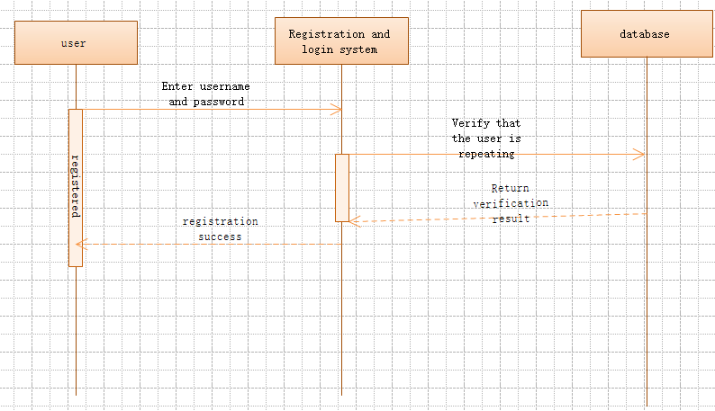

The user selects a favorite user name and sets a password that he or she feels safe. When the user enters the account and password into the registration system, the system feeds back the information to the database for verification to see if there is a duplicate username, if the system If the database user name is not duplicated, the registration is successful.

Log in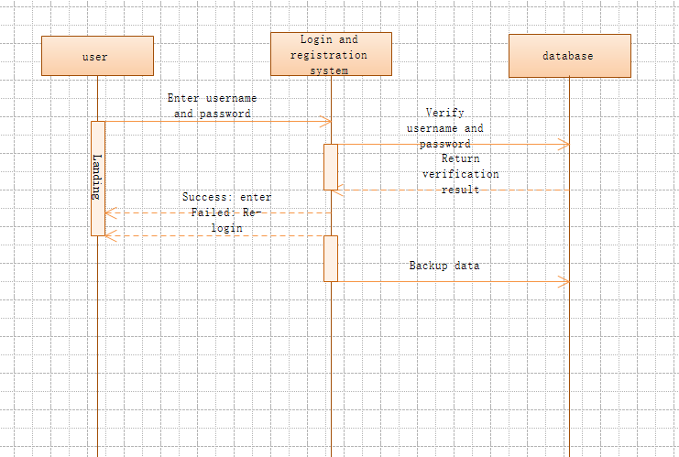

The user enters the user name and password when registering himself, and the login system feeds back the information to the database for verification. The database verification password and the user name are the same as the data stored in the database. If the verification succeeds, the login succeeds. If the verification fails, the login fails, and the account is re-entered. Login with password